**Active Directory – Basics**

## **Introduction**

In this lab exercise, we will use [VirtualBox](https://www.virtualbox.org/wiki/Downloads) Manager as our virtualization tool. It is one of the many available virtualization platforms.

A Windows Server Domain Controller is a server that runs a Windows Server operating system and is responsible for managing **security and access to resources** within a Windows domain.

Key functions of a Domain Controller include:

* **Authentication**: Validates users’ usernames and passwords when they log in.
* **Authorization**: Controls what users can access (files, folders, applications).
* **Centralized Management**: Enables administrators to manage users, computers, and policies in one place.
* **Active Directory (AD)**: Stores and organizes information about network resources (users, groups, computers, etc.).
* **Group Policy Management**: Enforces settings and restrictions across users and computers in the domain.

### **Prerequisites**

Ensure the following before starting:

* Your computer (Windows or macOS) has at least **16 GB of RAM**.
* [VirtualBox](https://www.virtualbox.org/wiki/Downloads) is downloaded and installed.
* The VDI for [Windows Server 2022](https://www.microsoft.com/en-us/evalcenter/download-windows-server-2022) is downloaded or you can go with ISO file also.
* For VDI you can skip the installation

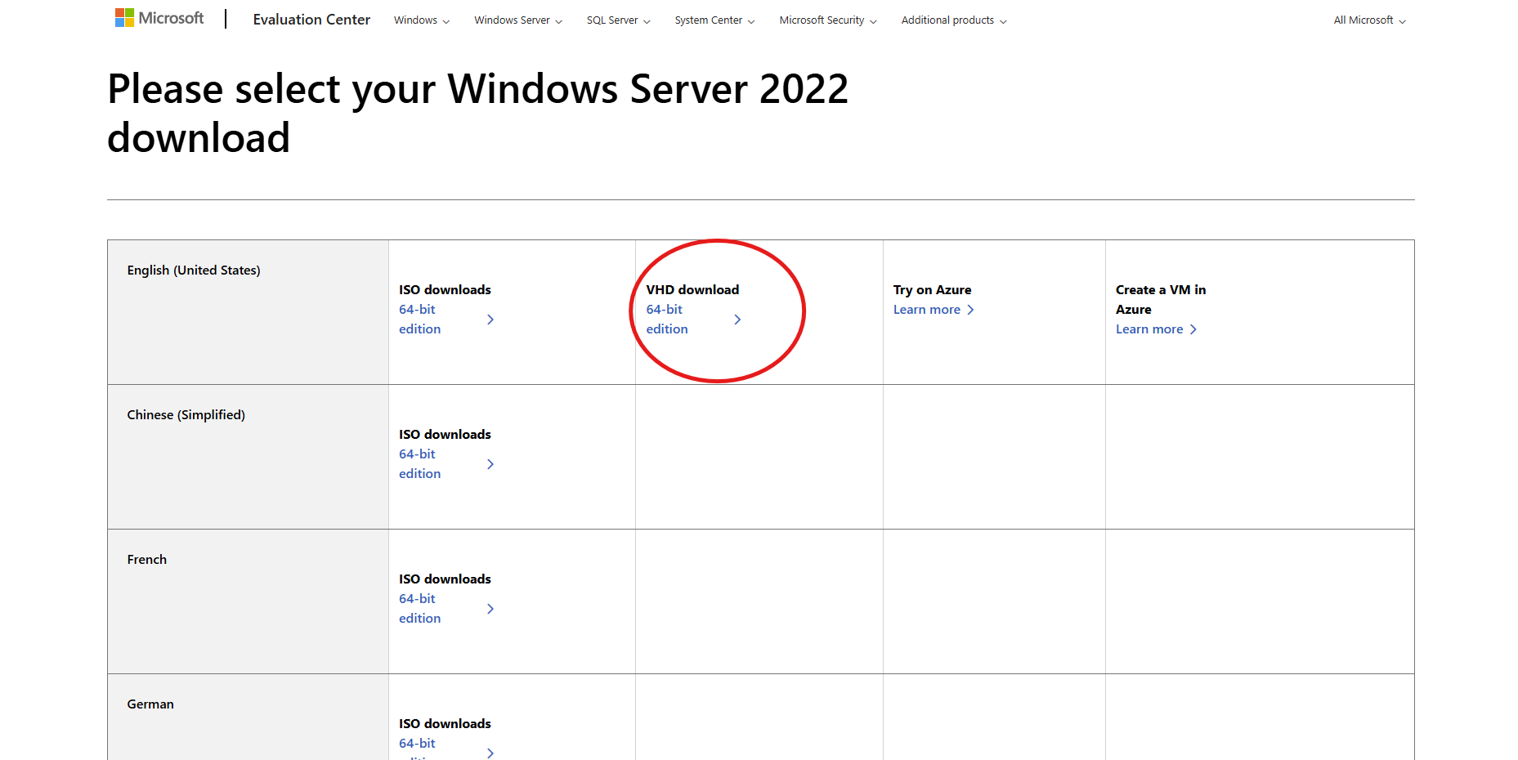

## **Step 1: Launch VirtualBox Manager and Mount your server**

* Click **New** to create and configure your virtual machine (VM).

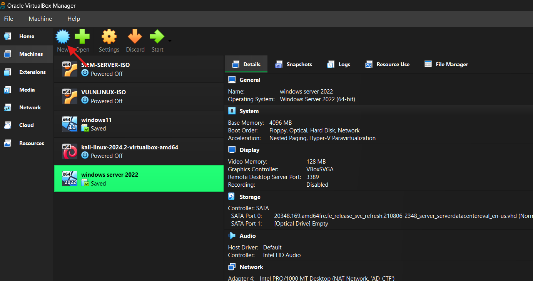

* Enter a unique name for your Windows Server. I used a “windows server 2022” for this lab.
* For the ISO image, leave it blank.
* For the OS field set it to Microsoft Windows
* For OS version select Windows Server 2022(64-bit)

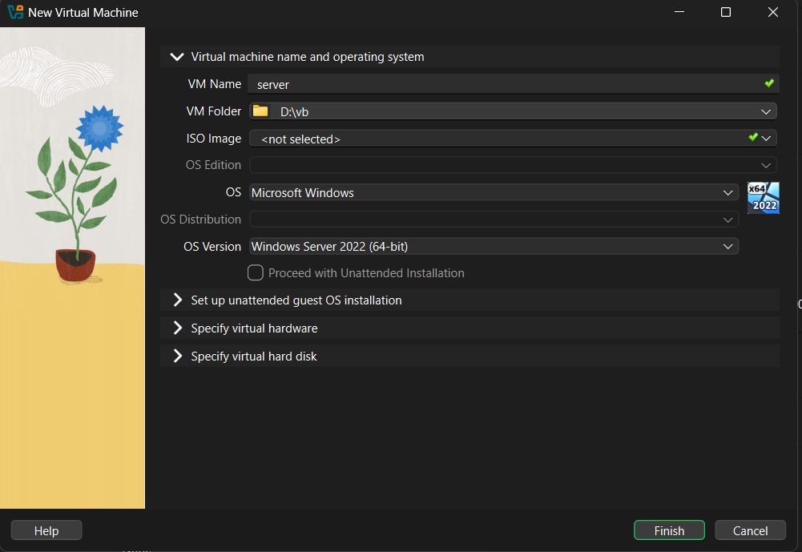

* Expand the **Hardware** dropdown, increase the **Base Memory** to at least **4096 MB**, and set the **Processor** to **2 CPUs**.

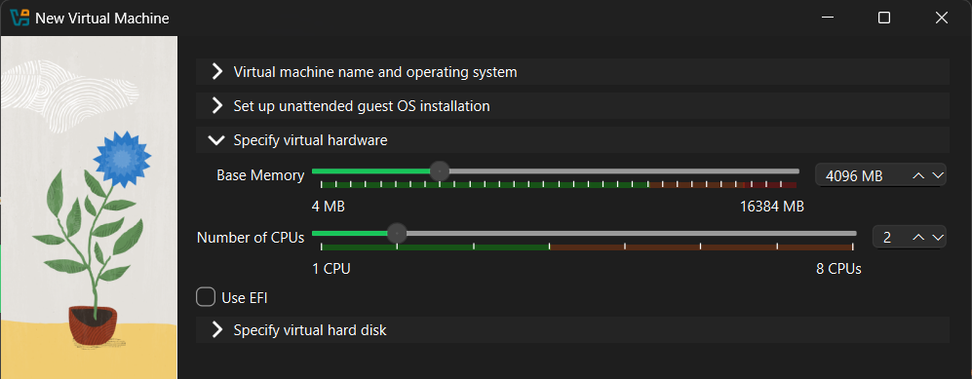

* Use an Existing Virtual Hard Disk File. From there, click the folder icon if you can see your vhd file select that otherwise click the add button and locate the windows server 2022 vhd file.

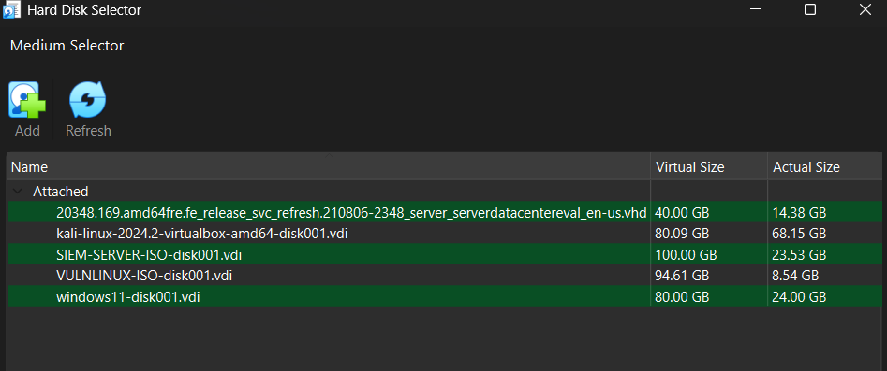

* Then you can see the vhd file of your server, choose it and click finish.

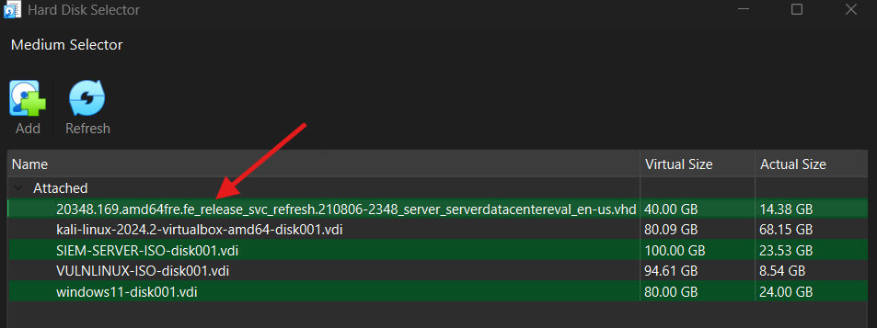

## **Step 2: Launch and Configure the Windows Server 2022 Virtual Machine**

* Ensure the **Server** VM is selected, then click **Start** in VirtualBox Manager.

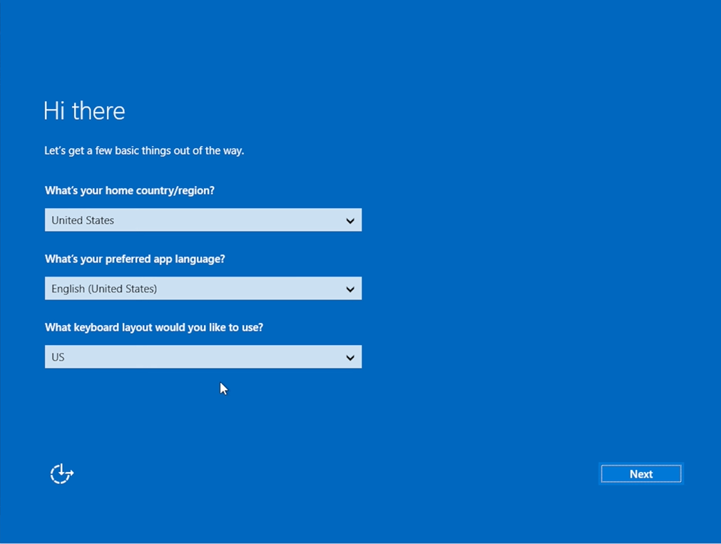

* Select **Next**.

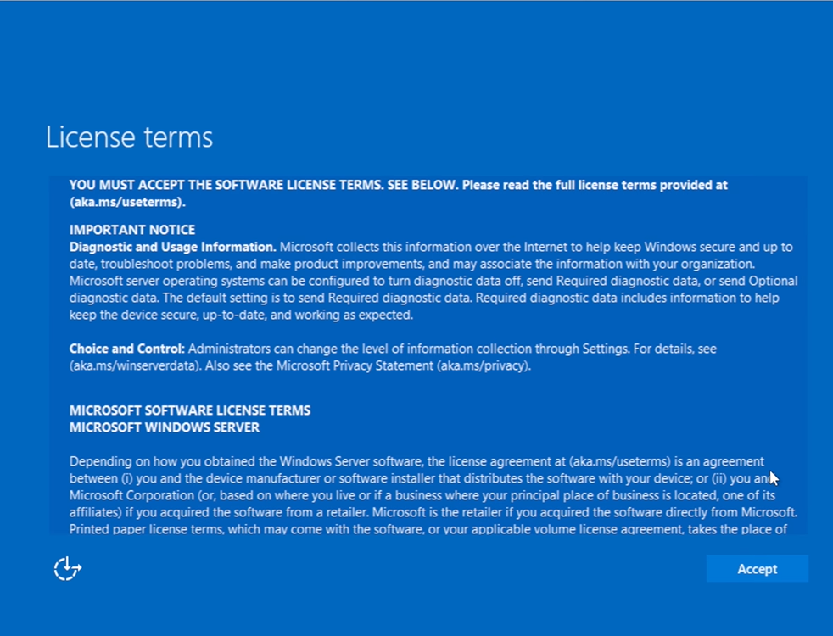

* Click **Accept.**

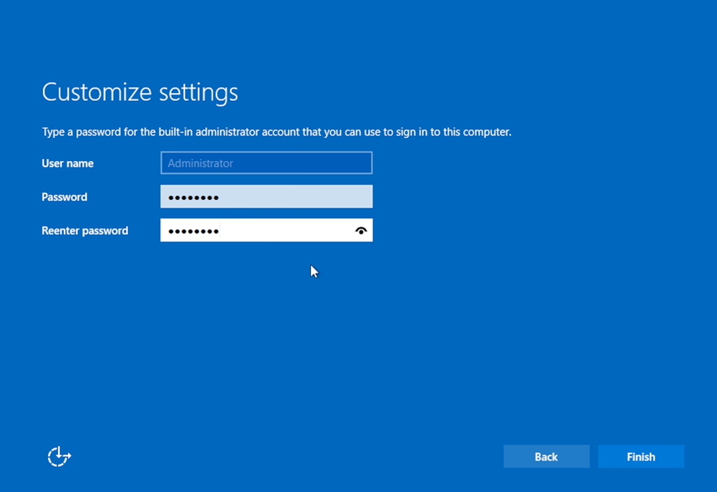

* Choose the **password** for the built-in administrator account that you can use to sign in to this computer for your **Windows Server 2022**.

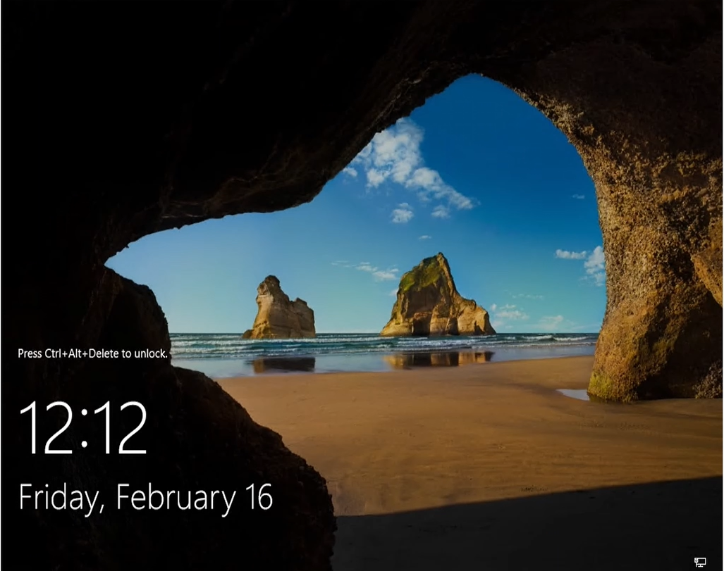

* Now that you see the lockscreen, you must press ctrl+alt+delete to unlock it. If you can't input the keys, press Host+Del (right ctrl+Del) or press input from the top, click on input and select the keyboard and click insert ctrl+alt+delete.

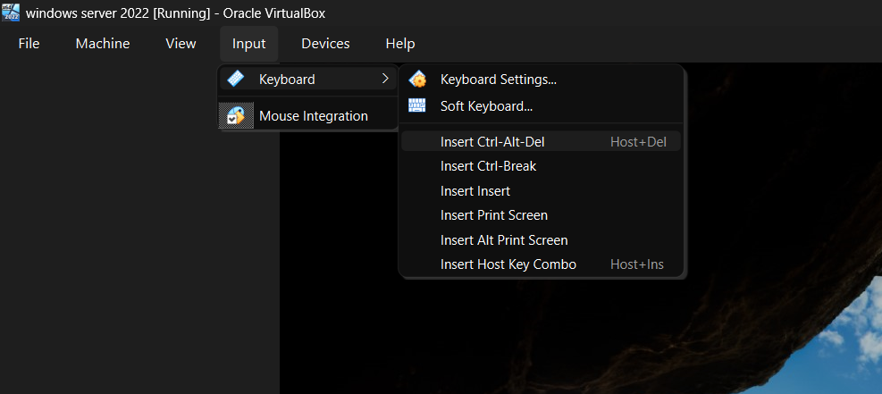

* Now enter your password and log in.

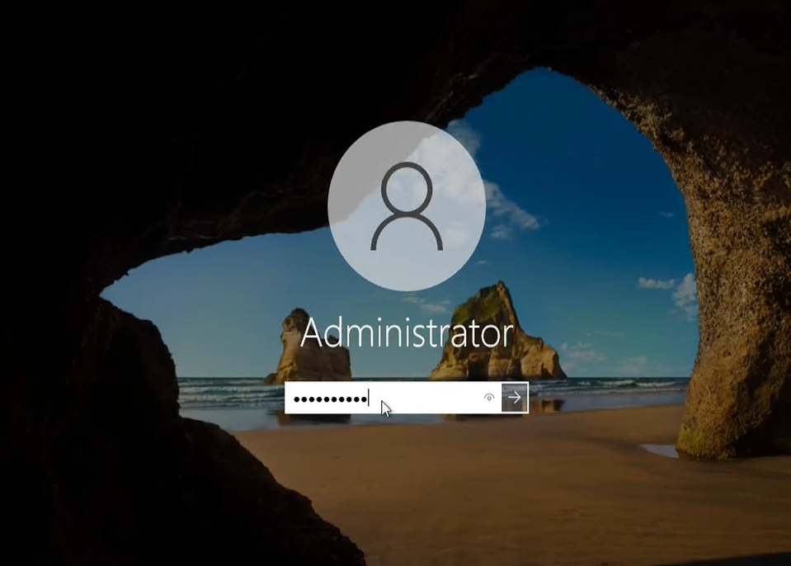

* Now you see an application called server manager.

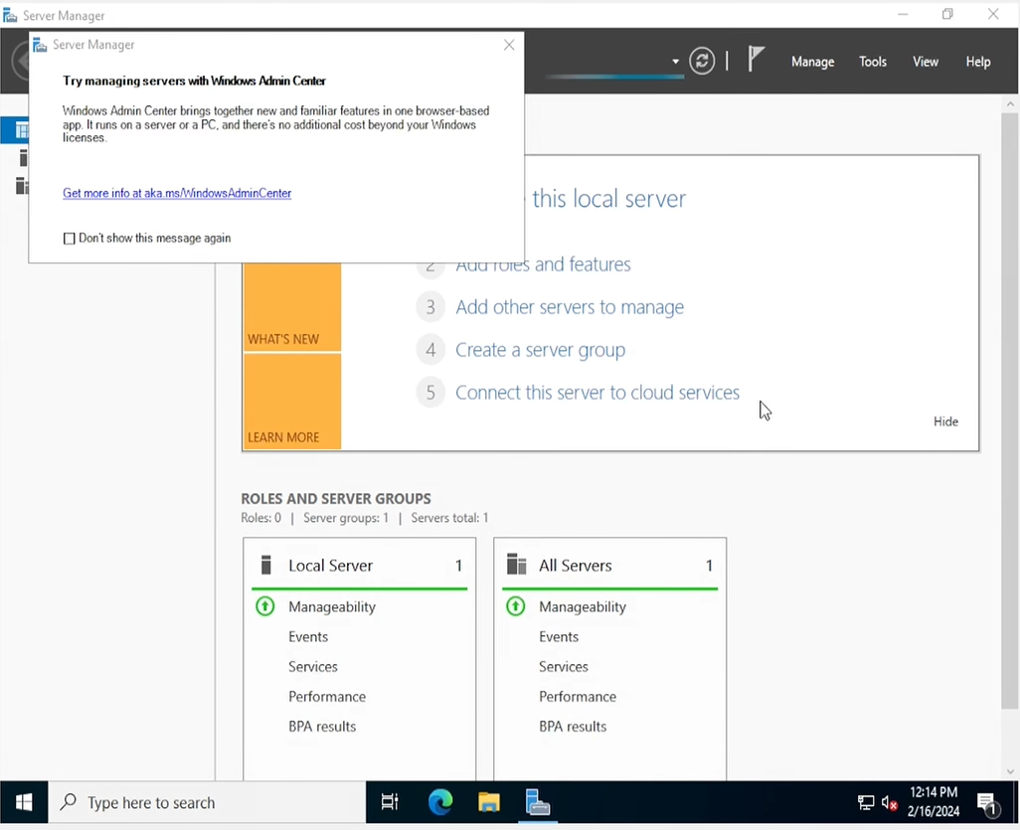

* Well done! Windows Server 2022 is now successfully installed and ready for use.

### **Rename the PC (Recommended)**

* Right-click the Windows Menu and select **Settings**.

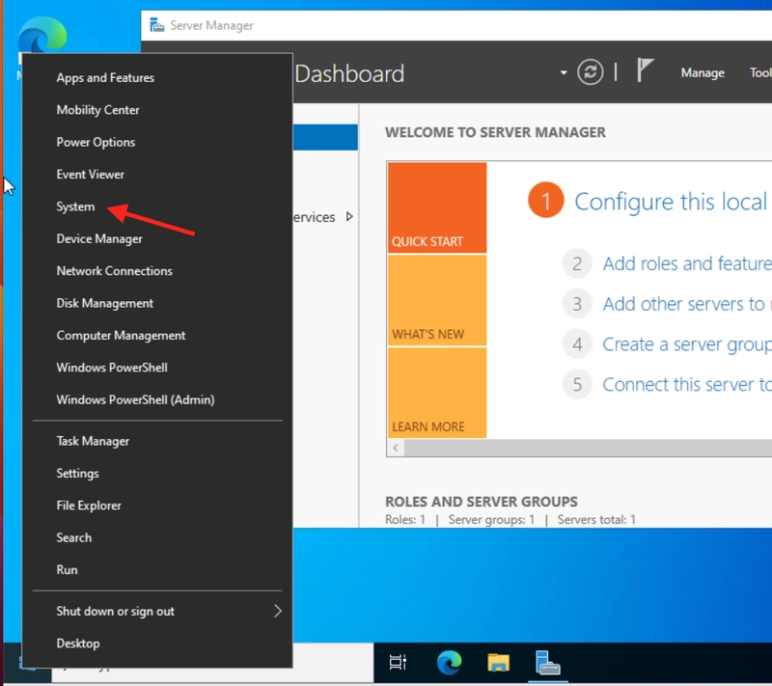

* Click **System**.

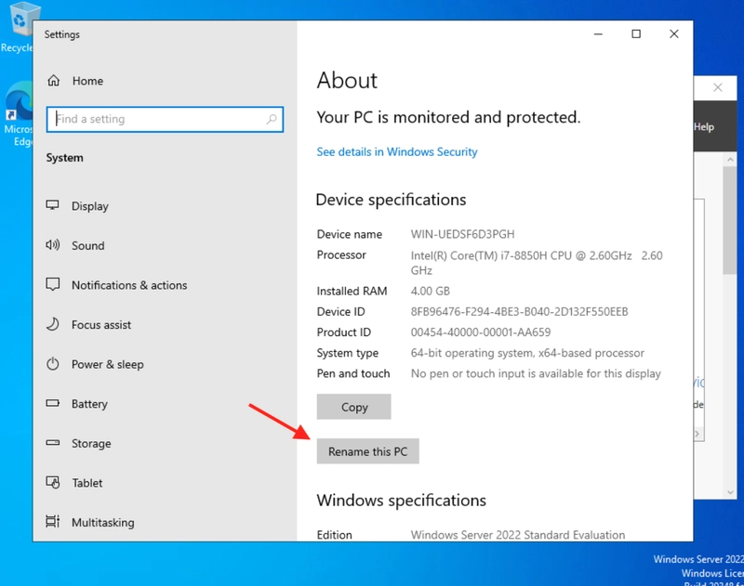

* Click Rename this PC. Enter the same name you used earlier in VirtualBox (e.g., *Windows Server 2022*), then click **Next**.

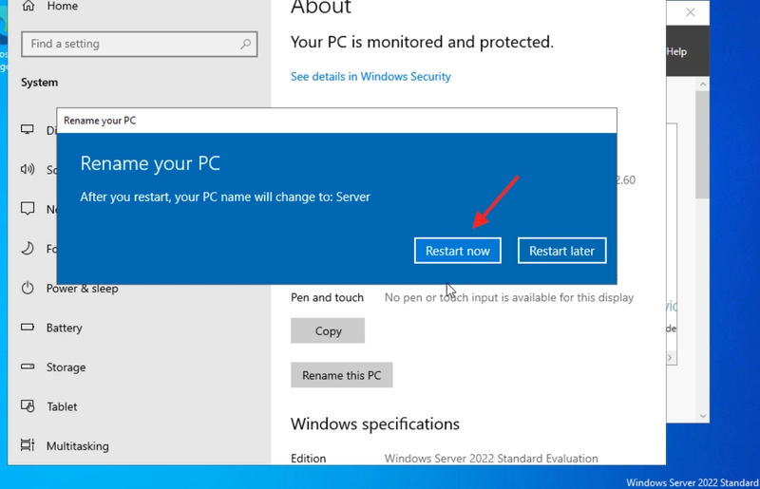

* Click **Restart now** to apply the changes.

## **Step 3: Create a Domain Controller Using Server Manager**

* When the VM starts, the Server Manager should open automatically.

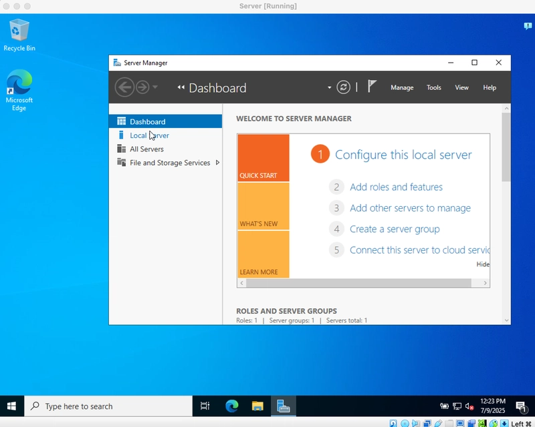

If not, click the **Windows Menu**, search for "Server Manager," and launch it.

* In Server Manager, select **Manage** > **Add Roles and Features**.

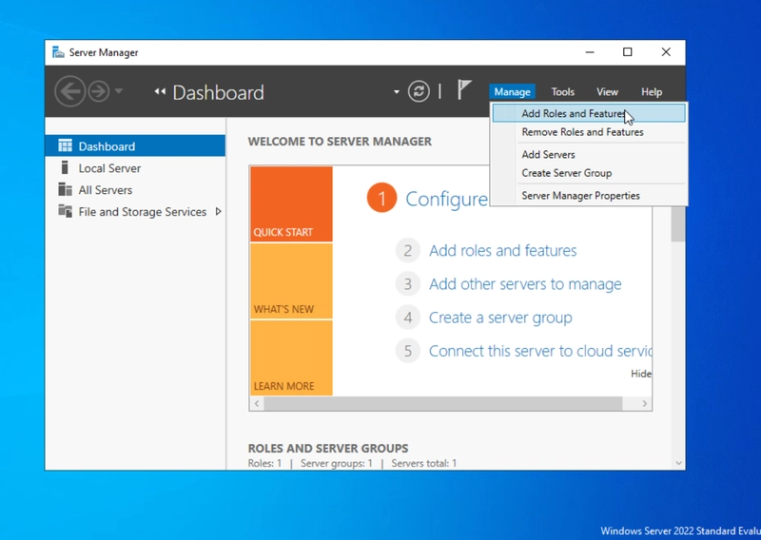

* On the **Before You Begin** page, click **Next**.

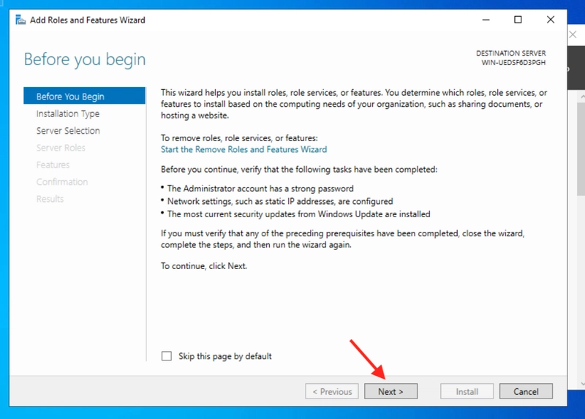

* On the **Installation Type** page, select **Role-based or feature-based installation**, then click **Next**.

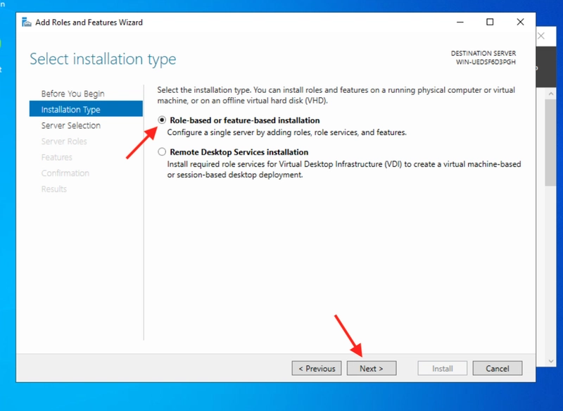

* On the **Destination Server** page, ensure your server is selected, then click **Next**.

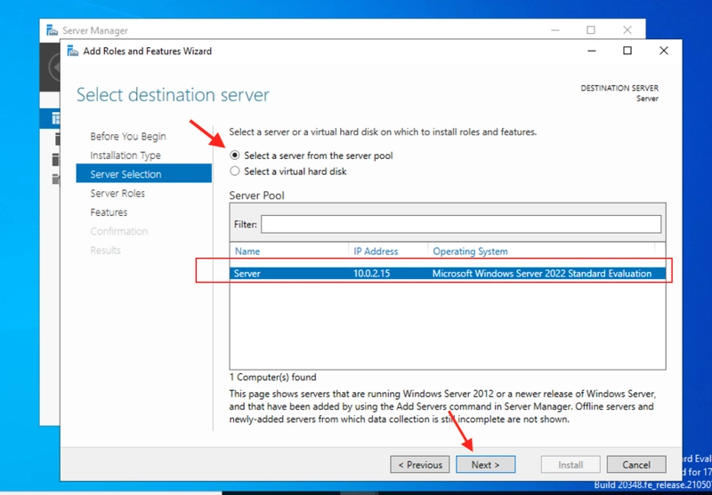

* On the **Server Roles** page, check **Active Directory Domain Services**. A pop-up will appear.

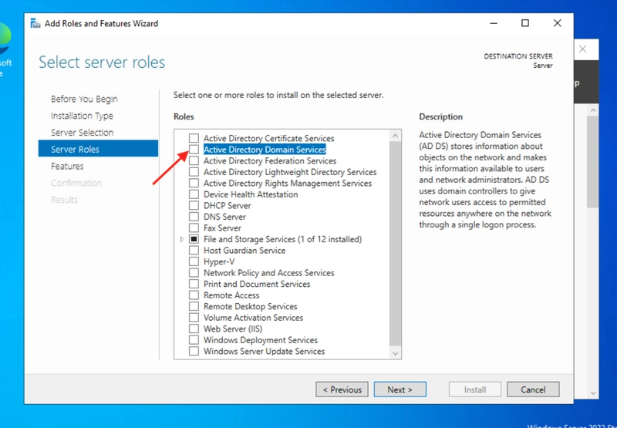

* Click **Add Features**, then **Next** through the next few steps.

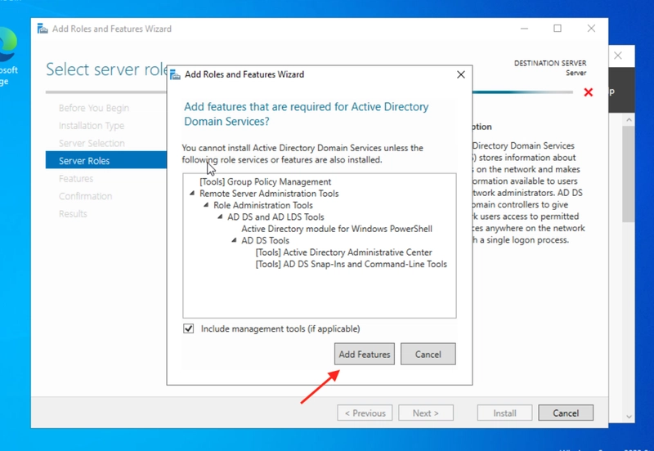

* On the **Confirmation** page, click **Install**. Installation may take a few minutes.

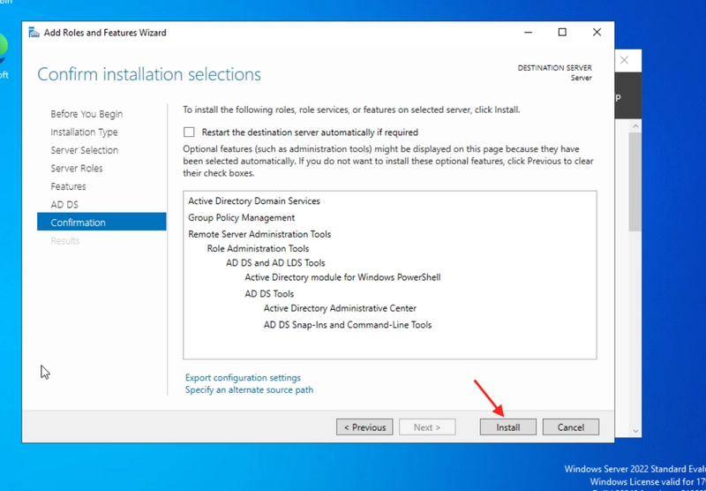

* Once completed, click the notification flag icon in Server Manager and select **Promote this server to a domain controller**.

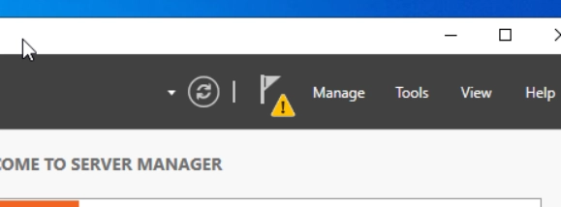  
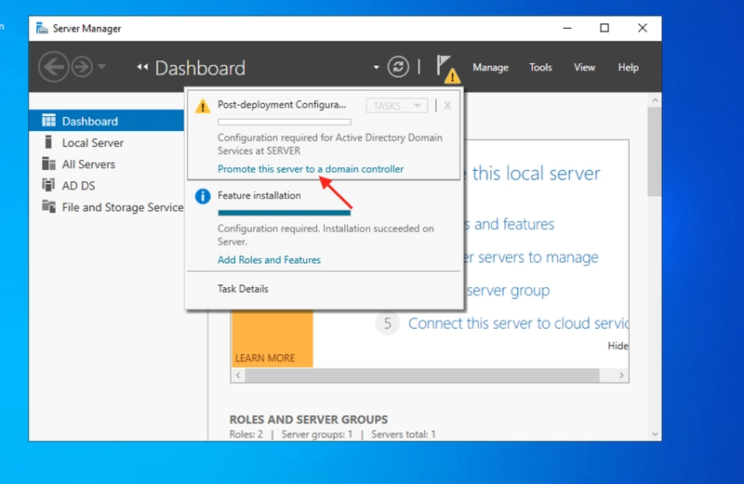

* On the **Deployment Configuration** page, choose **Add a new forest**, and enter a root domain name (e.g., google.com but I used ctf.local), then click **Next**.

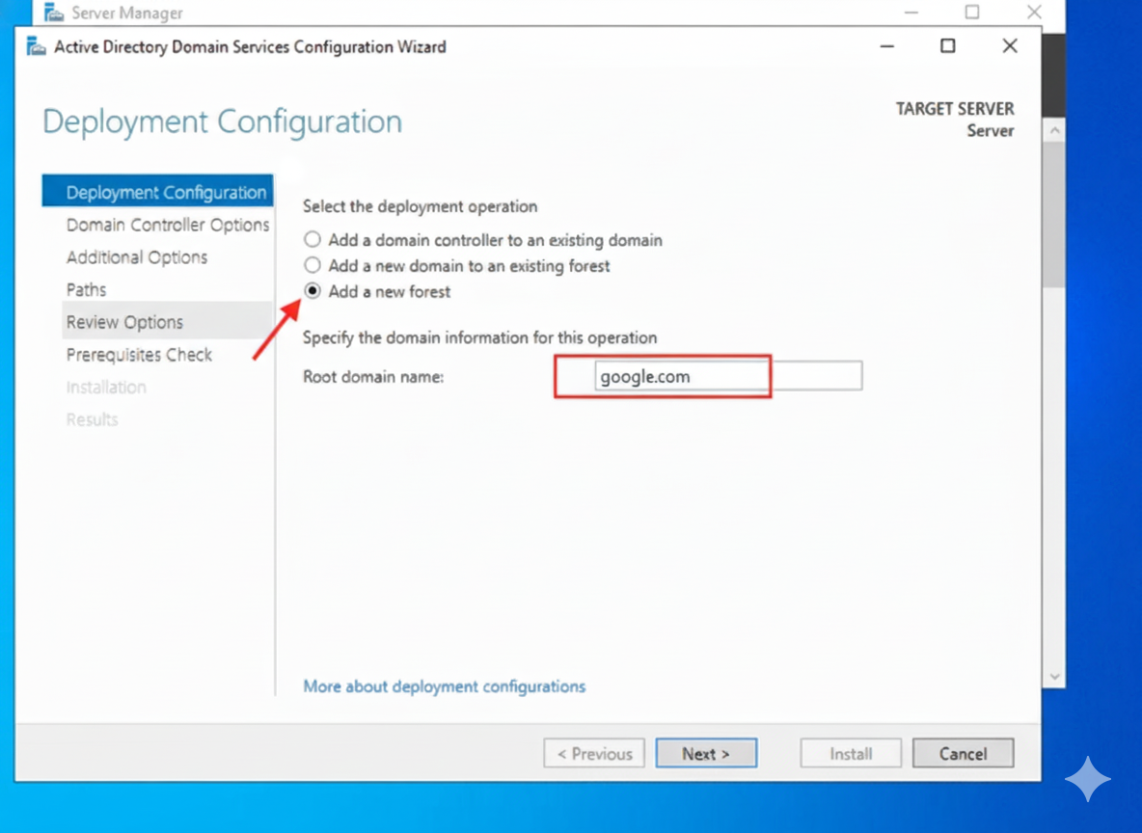

* On the **Domain Controller Options** page, accept the defaults and set up a **DSRM password** (used for recovery). Click **Next**.

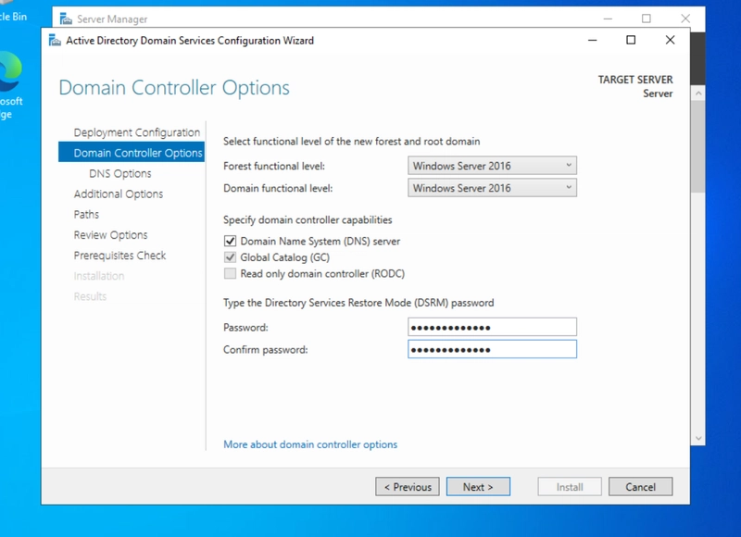

* Proceed through the **DNS Options**, **Additional Options**, **Paths**, and **Review Options** pages by clicking **Next**.
* On the **Prerequisites Check** page, click **Install**. This process may take several minutes, and the VM will restart when it is done.

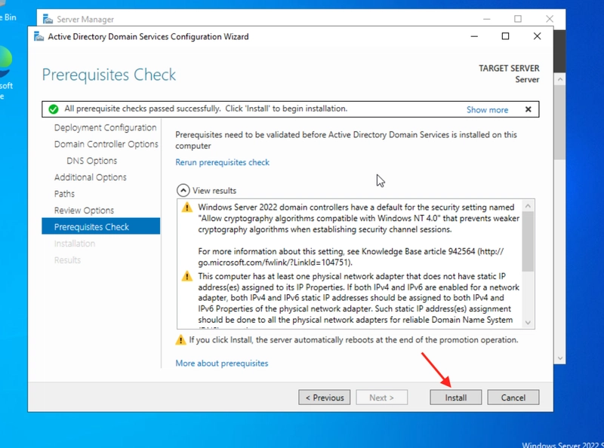

* After restarting, log in using your domain credentials, e.g., GOOGLE\Administrator(For me its CTF\Administrator).

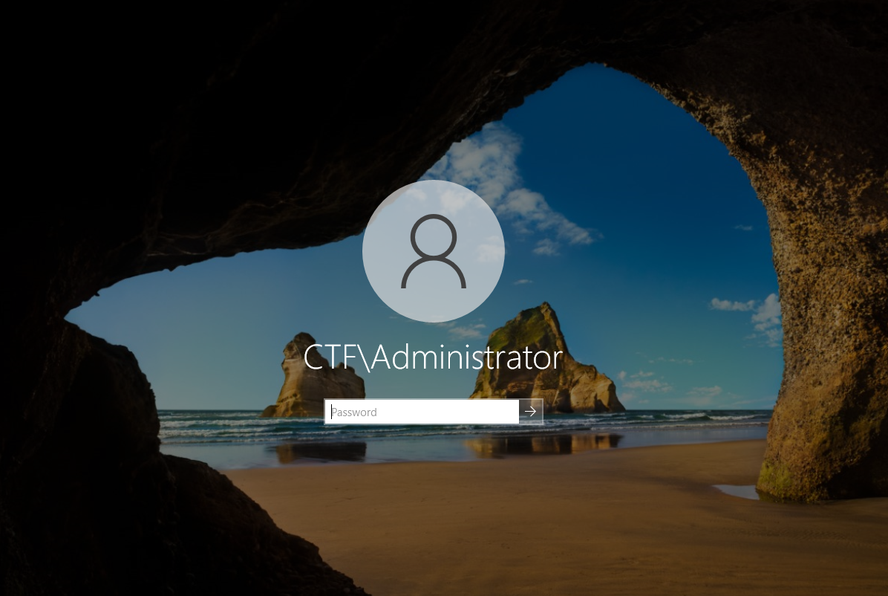

## **Step 4: Creating Organizational unit and Users**

* After openening server manager click on Tools option and select Active Directory Users and Computers

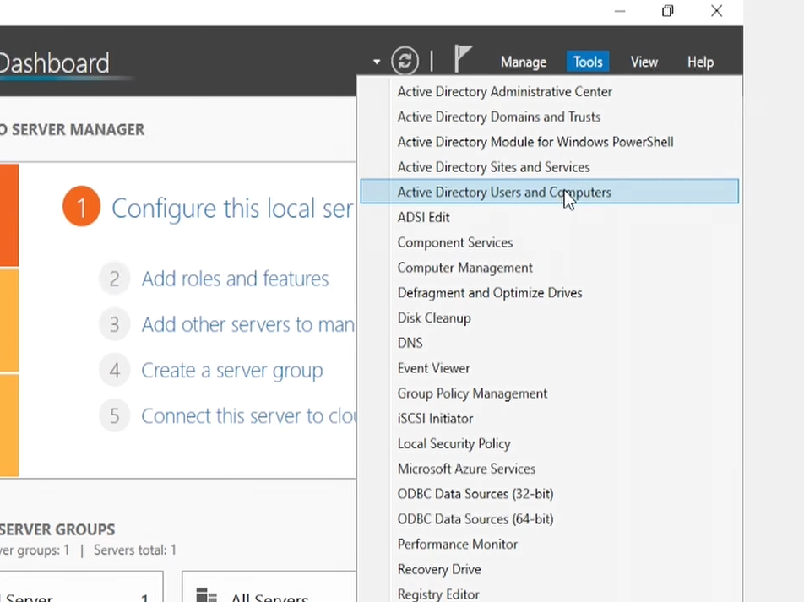

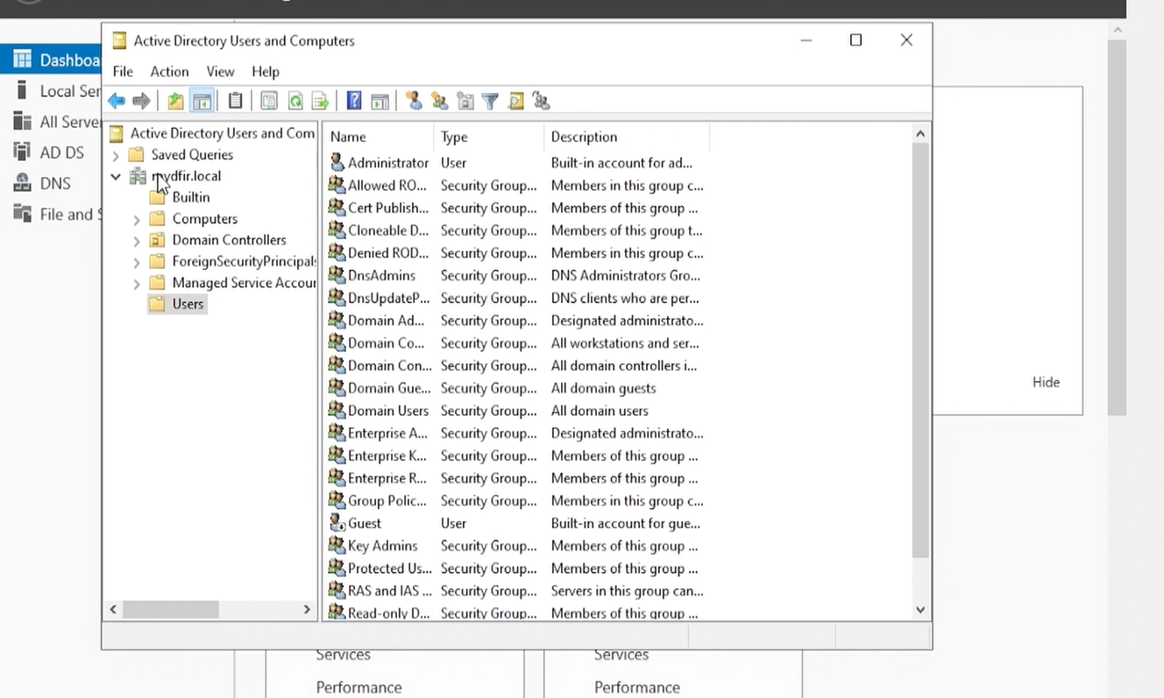

* As you are seeing this everything is default and in the User tab there are many users who are showing but in real life it's all divided into different groups like HR, IT and Sales etc.
* Right click on the domain name and click ‘New’ and select ‘Organizational unit’ and name it IT and repeat it to create another ‘Organizational unit’ and name it HR.

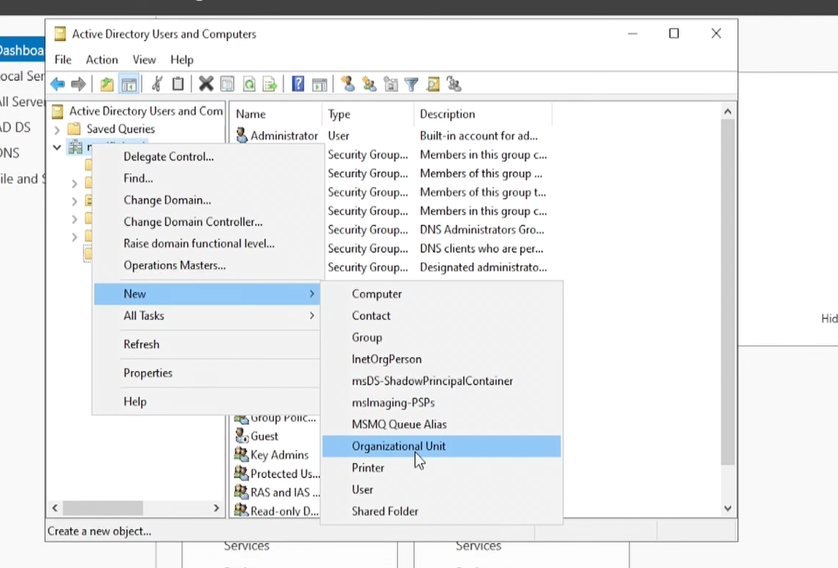

* After that we need to create users for each Organizational Unit (IT, HR).
* For that right click on the IT and click New then User.

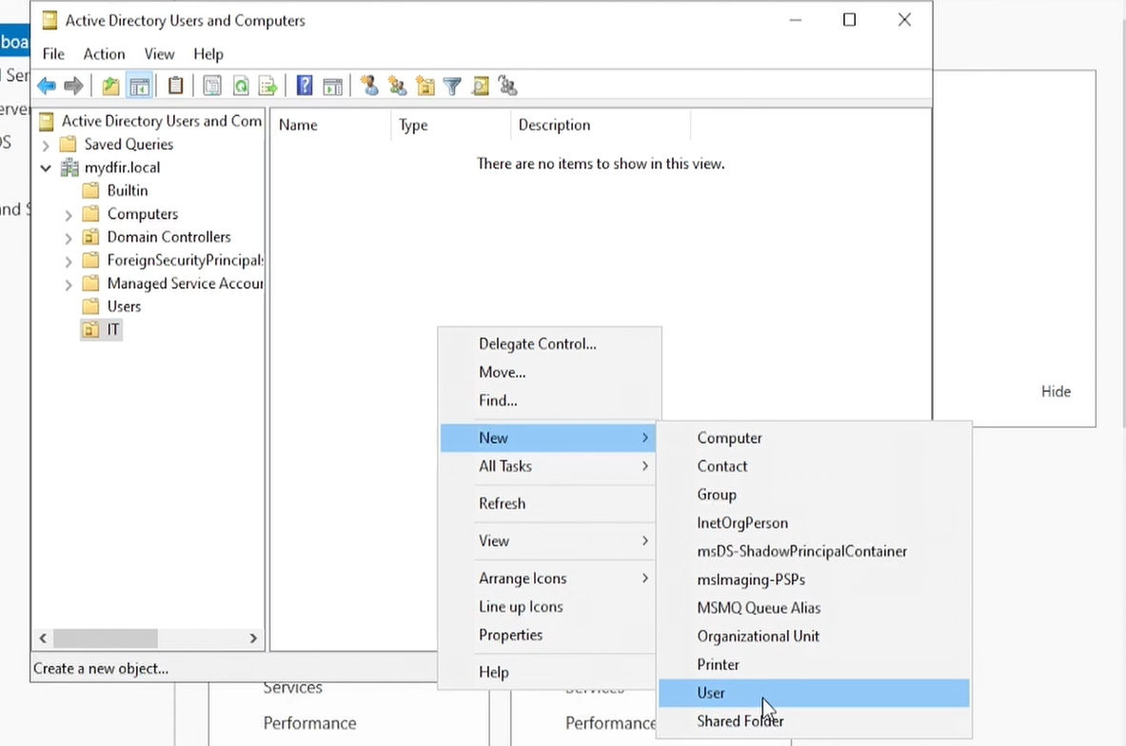

* Then you must fill all details of a user and put a logon name if you want same as the actual name you can do that, after typing the logon name click next.

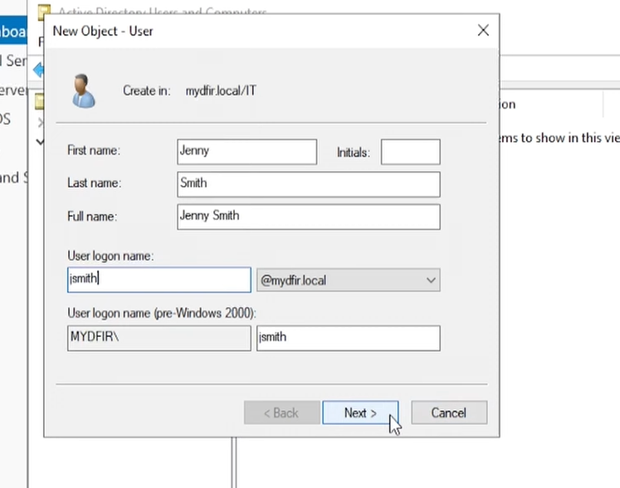

* Then type the password of the user and you can put conditions like the user must change the password at the next logon and user cannot change password.

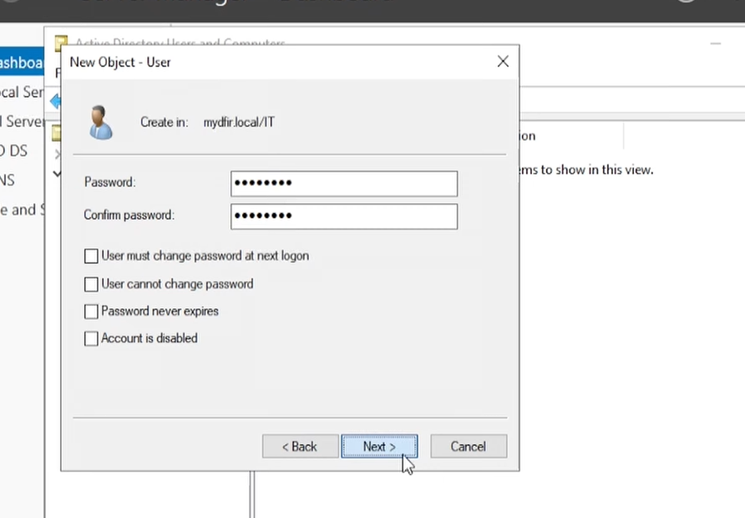

* Click next and finish it.

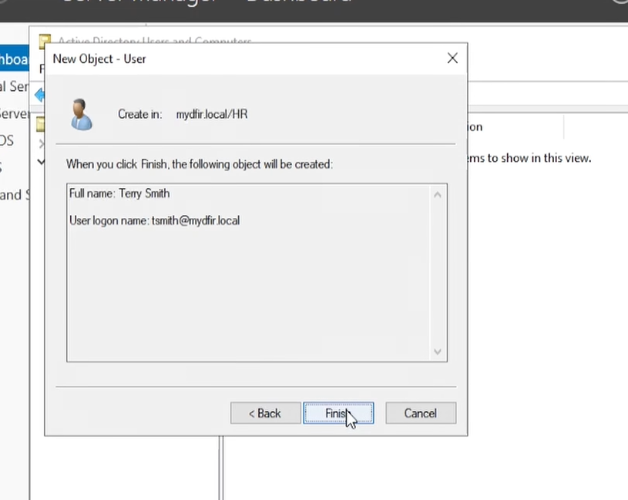

* Now repeat this to create a user on HR. Also, you can use auto script to add users and computers, but now we are creating to understand the basics of AD.
* Now you can login to this account for any windows that you must connect the windows and server to the same NAT network or in LAN.

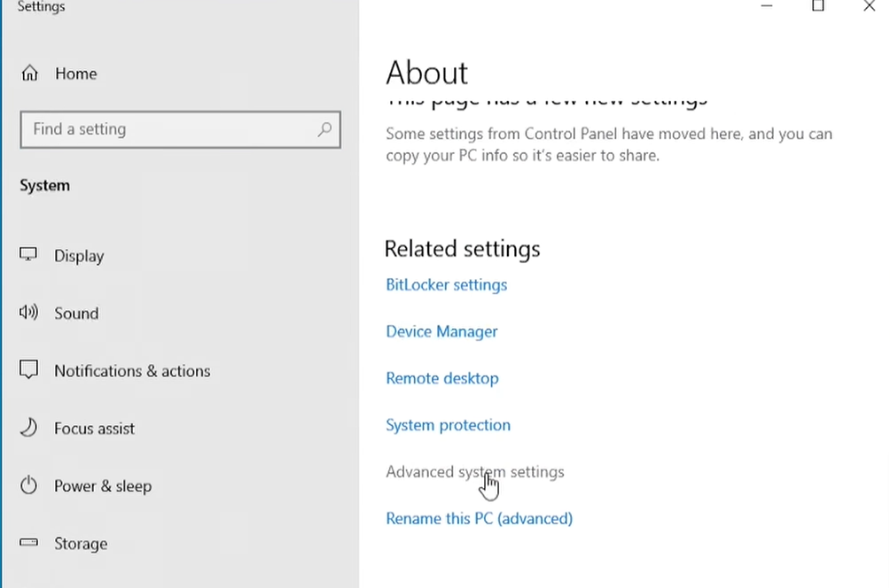

* For that open your Windows machine and go Setting then go to About then click Advance system settings

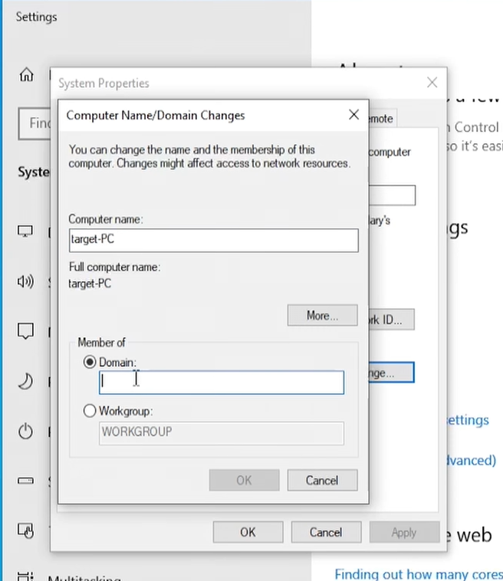

* In the Computer Name tab, click change then make sure you select Domain and input your domain name like google.com(*ctf.local*).
* After clicking ok you will get an error like An Active Directory Domain Controller (AD DC) for the domain "CTF.LOCAL" could not be contacted...
* This Happens because you DNS server pointing to google server You need to change that into **Our windows server.**
* For that you need to go to Network Connection select you Ethernet and click properties and double click **Internet Protocol version 4(TCP/IPv4).**

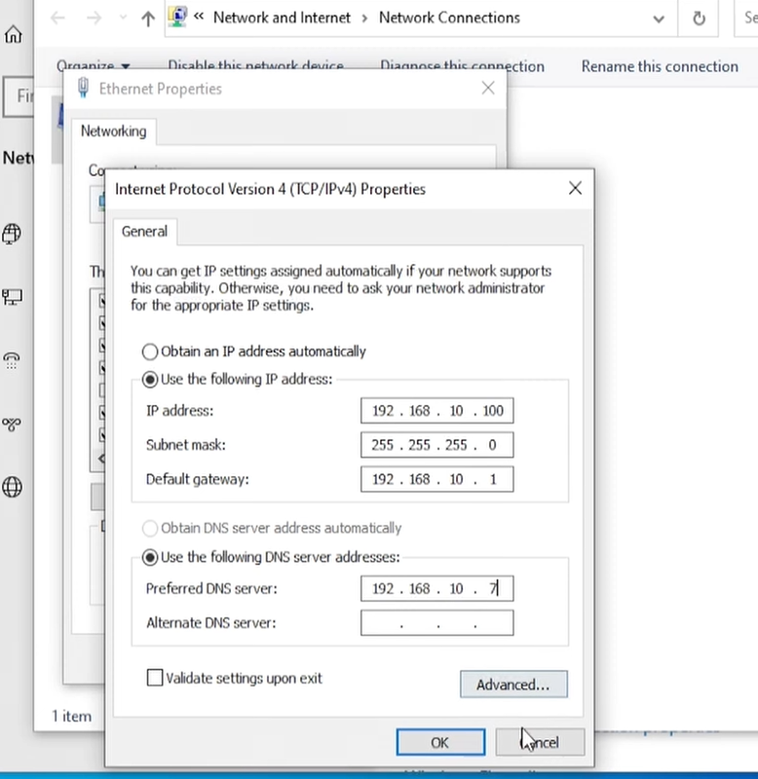

* And change the DNS server and click OK.

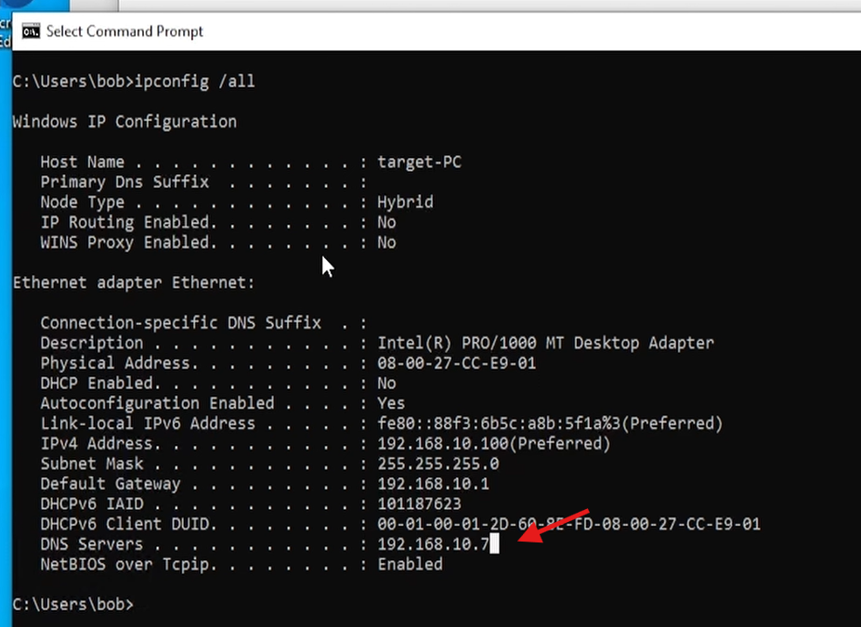

* Now check in cmd is the dns server has changed or not.

| ipconfig /all

* Now open Setting then go to About then click Advance system settings
* In the Computer Name tab, click change then make sure you select Domain and input your domain name like google.com(*ctf.local*)

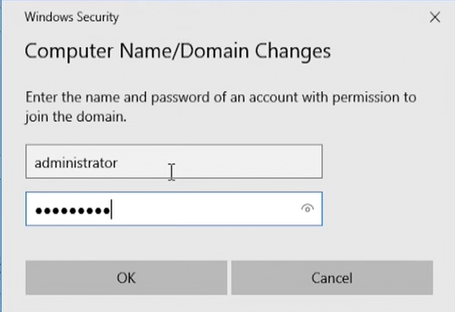

* Now you will see two fields username and password you must put the administrator details that you created for the Windows server 2022.
* Click ok and restart.
* Once we are on the log on screen sign in as other user now you will see our Domain name.

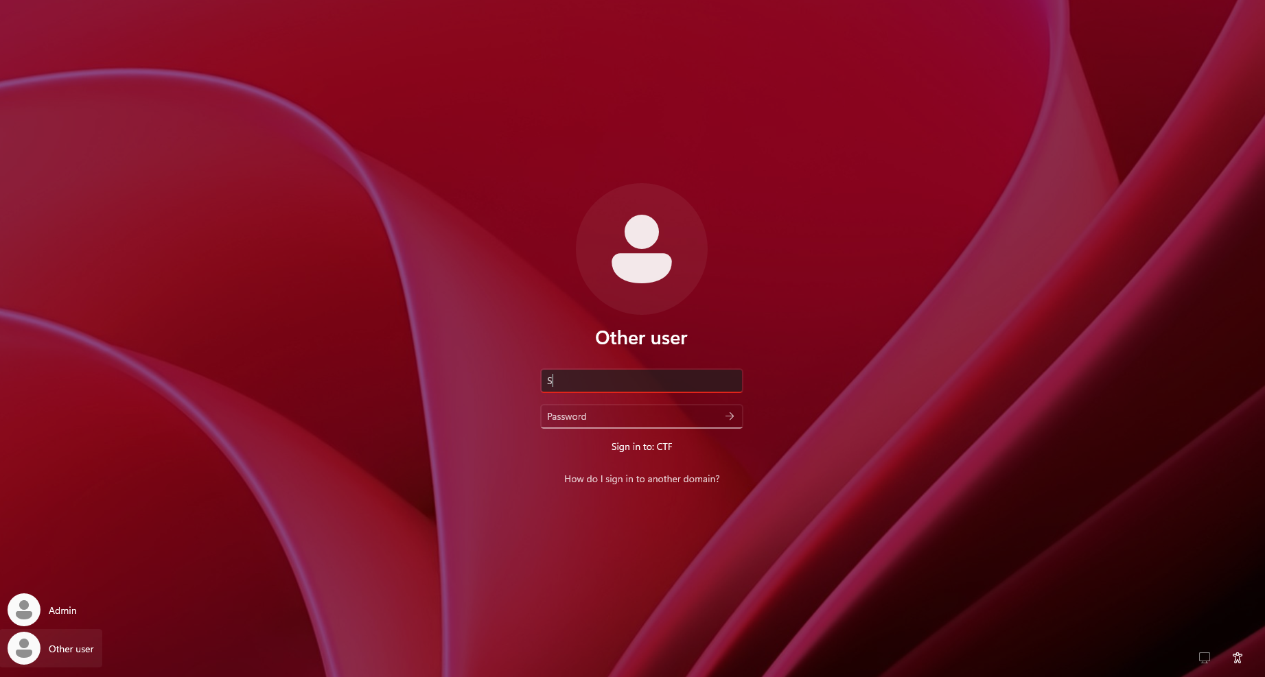

* Fill in the details of the user that you created in the Organizational Unit (IT or HR) like jsmith.

## **Conclusion**

You’ve successfully configured a Windows Server 2022 virtual machine and promoted it to a Domain Controller using VirtualBox. In this lab, you also created Organizational Units (such as IT and HR), set up user accounts within those OUs, and added a Windows machine to the domain. You then signed in using one of the newly created user accounts from the OU. This hands-on experience deepens your skills in virtualization, Active Directory management, and enterprise IT environments, giving you practical exposure for further exploration in Group Policies and advanced domain administration

Keep experimenting—and remember to **snapshot your VM** before making major changes. Happy virtualization!